Setup Custom Interfaces for Web Portal

Author: Tanya Leonce/Vinny Kelly

Contents

Allow Custom Interface to be Visible via Web Portal 3

Additional Notes 3

Executing Custom Interface in Web Portal 4

Enable Viewing/Downloading of Files via Web Portal 6

Troubleshooting Custom Interfaces in Web Portal 7

Ensure dbo.ExportKeys Table Exists 7

Custom Interface run on Web, but getting “ERROR: AHEmpExport.CreateFile ran successfully but no files were created for PayGroup: , PerControl: 201503311” 7

Limitations of Running Custom Interfaces in Web Portal 9

3 Minutes Timeout Window 9

Lose Control of Export Path Designation 9

Sending On-Demand Files via UDES (Workaround) 9

WST Request for Access to UltiPro Web (User Account – No Impersonation) 10

# Allow Custom Interface to be Visible via Web Portal

1. In order to make a custom interface visible via Web Portal, it must be added to dbo.CustomTemplates table.
2. Below is the script to add a Custom Interface by FormatCode:

DECLARE @FormatCode VARCHAR(10)

SET @FormatCode = 'EFORMATCODE';

INSERT INTO dbo.CustomTemplates(CreationDate,Engine,EngineCode,IsActive,ModifiedDate)

SELECT CreationDate = GETDATE()

,Engine = AdhEngine

,EngineCode = AdhFormatCode

,IsActive = 1

,ModifiedDate = GETDATE()

FROM dbo.AscDefH WITH (NOLOCK)

WHERE AdhFormatCode = @FormatCode AND adhFormatCode <> 'ECESWAGE' AND adhEngine = 'EMPEXPORT'

AND NOT EXISTS (SELECT 1 FROM dbo.CustomTemplates WHERE EngineCode = AdhFormatCode)

1. Confirm the Custom Interface has been loaded to the dbo.CustomTemplates table.
2. Once the FormatCode shows in the dbo.CustomTemplates table, then it is now available via Web Portal.

## Additional Notes

* Migrating Interface to Web Script: <https://ulti.box.com/s/xlg4wu86ga02wh5al9flatwf0w4pb5ts>
* By adding the Custom Interface to the dbo.CustomTemplates table, it allows the custom to be visible to run via the Web Portal, but the FilePath / FileName will need to be configured to run on Web, see below:
  + Enable Viewing/Downloading of Files via Web Portal
* Any interfaces running via the Web Portal has a 3 minute threshold to complete. If it does not complete within the 3 minute threshold, then the Web the process will give a timeout error which can be identified in Process Automation Center during troubleshooting.
* Please ensure all Export Sessions have unique Descriptions so that they can be easily identified via the Web since the ExportCode value is not visible to the customer.

# Executing Custom Interface in Web Portal

1. Log into customer’s Web Portal.
2. In the menu bar, select Transfer Data > Manage Interfaces.
3. Locate the Custom Interface in the list, then for the designated Export Session, then click “Run” button.

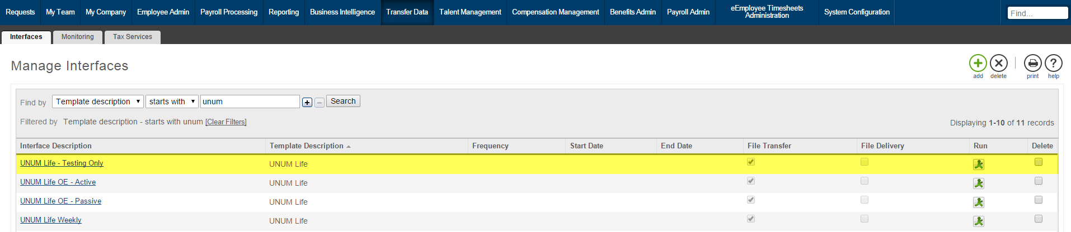

1. In the On-Demand “Run” screen, then you can make any Company or Data Selection Filters, set the Date Range, and select any Sequences.

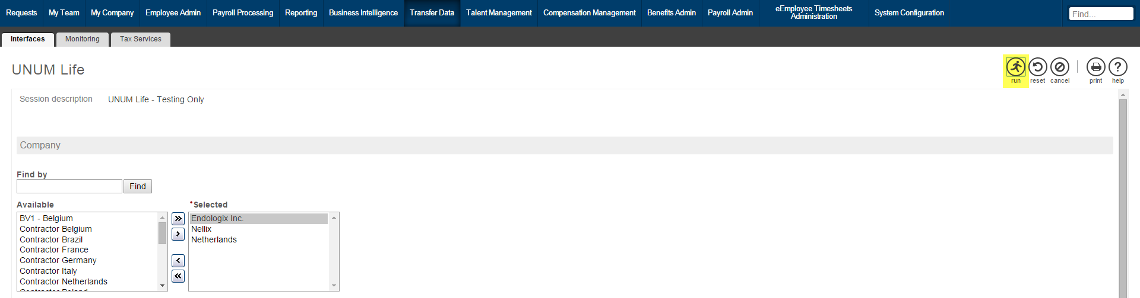

1. Once you have made all the selections, then click on the “Run” button at the top-right hand corner of the screen. This will start the process.
2. Once you have kicked off the process, then you will be re-directed back to the Transfer Data > Manage Interfaces screen.
3. You can check to see if the process has completed by clicking on the “Monitoring” tab at the top of the screen:

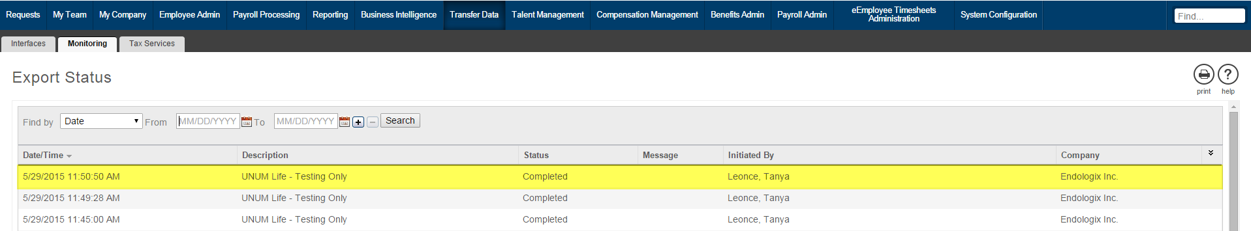

1. If the process was successful, then the Status will show “Completed”.
2. **NOTE:** For Automated Schedules, you must have a dedicated Export Session to setup the Web Schedule. The reason for this is because if you manually run the interface with a Web Schedule on it, then a Ghost Job may be created and can cause issues with the Automated Schedule. If a Ghost Job happens, then please refer to KB Article: <https://ultimatesoftware.my.salesforce.com/kAX3200000002bn?srPos=0&srKp=kaX&lang=en_US>

# Enable Viewing/Downloading of Files via Web Portal

* For customer’s to be able to view/download files in the Reporting > File Transfer screen, then the following must be setup:
  + ‘UseFileName’ must be set to ‘Y’ in U_dsi_Configuration table.
    - **NOTE:** If running via BackOffice, then you will need to set the FilePath and FileName in the “FileName” text box in Export Session.
  + ‘ExportPath’ must be set to NULL in U_dsi_Configuration table.
  + Remove any updates to the ‘ExportFile’ field in U_dsi_Parameters within BuildDriverTable SP.
* Once a file has been generated via the Web Portal, then it can be viewed/downloaded from the Reporting > File Transfer screen:

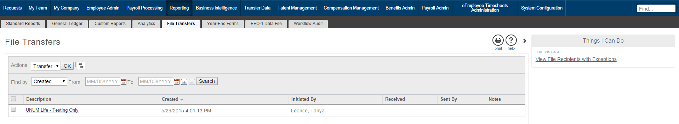

* The ‘TestPath’, ‘OnDemandPath’, and ‘OEPath’ will NOT work if the Web Portal FilePath / FileName is enabled for viewing/downloading.
* For files generated via the Web, then there are two default file naming conventions based on whether the file is an Employee History.
  + **Employee History Export FileName Convention:**

*[Company's contract number]_[Master company's COID]_EEHISTORY_[template code]_[session code]_SCHED_[YYYYMMDD]_[HHMMSS].txt*

* **NOTE:** If the file is being scheduled via UDES, then the UDES rule will need to reflect the naming conventions listed above and UDES will need to rename the file to the vendor’s approved filename.
* The Web will automatically place the files in a folder with naming convention similar to the following:
  + \\us.saas\[First 2-3 Char of SaaS Env]\[SaaS Env]\Downloads\V10\Exports\[Company Code]\EmployeeHistoryExport\
  + If this folder does not exist, then you will need to create an “EmployeeHistoryExport” folder in the root of the customer’s folder.
* An Example of File Path and FileName generated by Web Portal:

\\us.saas\n2\N23\Downloads\V10\Exports\ENDOL\EmployeeHistoryExport\END1001_2F4AF_EEHISTORY_EUNUMLFEND_TEST_20150529_160045.txt

# Troubleshooting Custom Interfaces in Web Portal

## Ensure dbo.ExportKeys Table Exists

1. Log into the customer’s UltiPro database.
2. Run a SELECT query against dbo.ExportKeys table to see if it exists.
3. If the dbo.ExportKeys table is missing, then run the script below to create the table:

IF OBJECT_ID('ExportKeys','U') IS NULL

CREATE TABLE [dbo].[ExportKeys](

[DateTimeCreated] [datetime] NOT NULL DEFAULT (GETDATE()),

[ExportCode] [nchar](10) NOT NULL,

[OriginalExportCode] [nchar](10) NOT NULL,

[SystemId] [char](12) NOT NULL,

CONSTRAINT [PK_ExportKeys] PRIMARY KEY CLUSTERED

(

[SystemId] ASC

)

)

GO

1. Once the table has been loaded, then the switchbox_v2 will recognize the custom interface by ExportCode.
2. If the dbo.ExportKeys table does not get populated, then the Web Code is not functioning properly and a Jira ticket will need to be opened to ensure the Web Code is deployed and working.
3. NOTE: The dbo.ExportKeys table is only available with UltiPro Version 12.01 or later.

## Custom Interface run on Web, but getting “ERROR: AHEmpExport.CreateFile ran successfully but no files were created for PayGroup: , PerControl: 201503311”

* No File is generated, but it really did run successfully.
  + This could be a valid message and misleading if we have 'NoEmpty' = 'Y' in U_dsi_Configurations table.
* This could be related to a File Permissions on the "ProcessAutomation" folder where SQL Tools service account needs to be added.
  + **Troubleshooting Steps:**
    - Check U_dsi_InterfaceProcesses Table for the StepName = ‘BCPCOMMAND’ for the BCP Command used to generate the file.
    - Run the following BCP command in SSMS to see if any errors occur:
      * EXEC master.dbo.xp_cmdshell '<PASTE BCP STATEMENT HERE>'
    - If the following Error Message is received “Error = [Microsoft][ODBC Driver 11 for SQL Server]Unable to open BCP host data-file”, then a Jira is needed for SaaS to add SQL Tools service account. Example Jira to Reference: <https://ultidev/browse/SD-3401892>
  + Other Jira(s) to reference: <https://ultidev/browse/SD-3858556> and <https://ultidev/browse/SD-3905451>
* The "ProcessAutomation" folder is pointing to "c:\temp\" folder instead of a SaaS Environment folder. Jira is required to resolve this.
  + Example Jira to reference: <https://ultidev/browse/SD-3740175>
* There's an issue with the interface not allowing it to generate.
  + If the “UseFileName” is NOT set to ‘Y’ in U_dsi_Configuration, then this error occurs in the Transfer Data > Integration Studio screen on the Web.
  + Ensure “UseFileName” is set to ‘Y’ so the file is generated to Reporting > File Transfer screen in the Web.

**NOTE:** Interfaces run via Web Schedule and Payroll Automation will delete Empty Files and will not transmit to vendors or place in File Transfers folder, this was rolled out by design in 2018 R2 Release. Nat is leading this to get PDIS to allow us to send Empty Files to Vendors that require it.

* Jira(s) for tracking <https://ultidev/browse/ULTI-343597> and <https://ultidev/browse/ULTI-337901>

# Limitations of Running Custom Interfaces in Web Portal

## 3 Minutes Timeout Window

The Web Portal only allows a 3 minutes window in which a custom interface must complete in order to generate a file. If a custom interface process takes longer than 3 minutes on average to run, then it may not be the best candidate to run on the Web Portal.

## Lose Control of Export Path Designation

Custom Interfaces must either run via the Web Portal or BackOffice, but it is not recommended to allow it to run on both environments. When the custom interface is run via the Web Portal, then you will lose the ability to specify the Export Path. When running custom interfaces via BackOffice, then you can manage the various Export Paths (i.e., TestPath, OnDemandPath, etc).

## Sending On-Demand Files via UDES (Workaround)

Previously, we did not have the ability to send files via UDES when the Custom Interface was run “on-demand” via the Web Portal. In Spring 2015 Release, the Development Team provided the ability to send files via UDES/SFTP when run “on-demand” only for Open Enrollment. If a client would like to send a file via UDES/SFTP running it “on-demand”, then it must contain “OE” in the Export Code (AscExp.ExpExportCode).

Additional Limitations to Consider: <https://ulti.box.com/s/8zjvgej6sjj9p4acxdvijsbbnibiycx0>

# WST Request for Access to UltiPro Web (User Account – No Impersonation)

**Please Note:** We use “Impersonation” to log into Web, request WST if you need access to Web for your User Account.

1. Log into UltiPro WST at <https://wst.ultimatesoftware.com/>
2. Click on “Security Access” button on the homepage, see below:

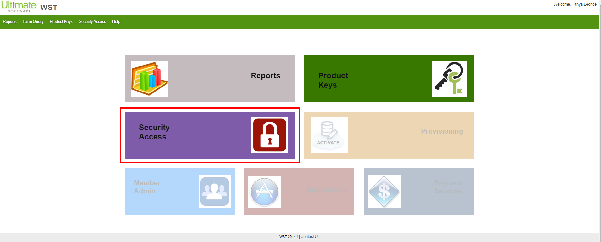

1. Click on "New Request" to start the New Request Wizard, see below:

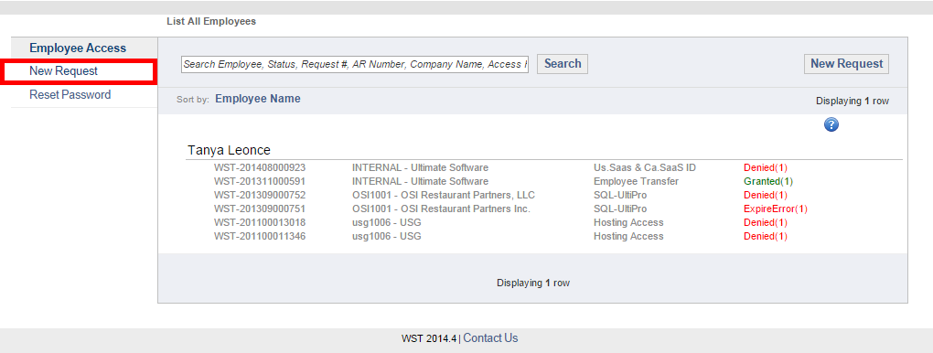

1. For Select Request Type, choose Priority in the drop-down and set Temporary Access Date Range. See below:

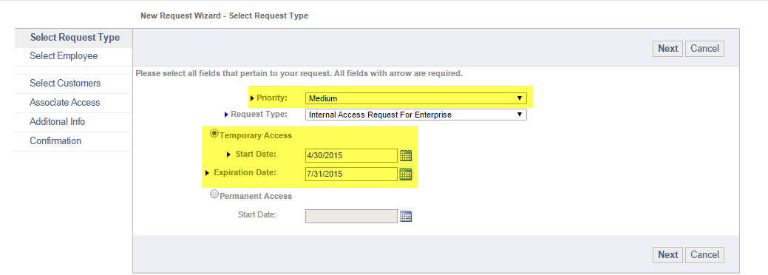

1. For Select Employee, confirm the information is correct and then click Next.
2. For Select Access, then choose the Products you require access. Expand Products and check boxes. See below:

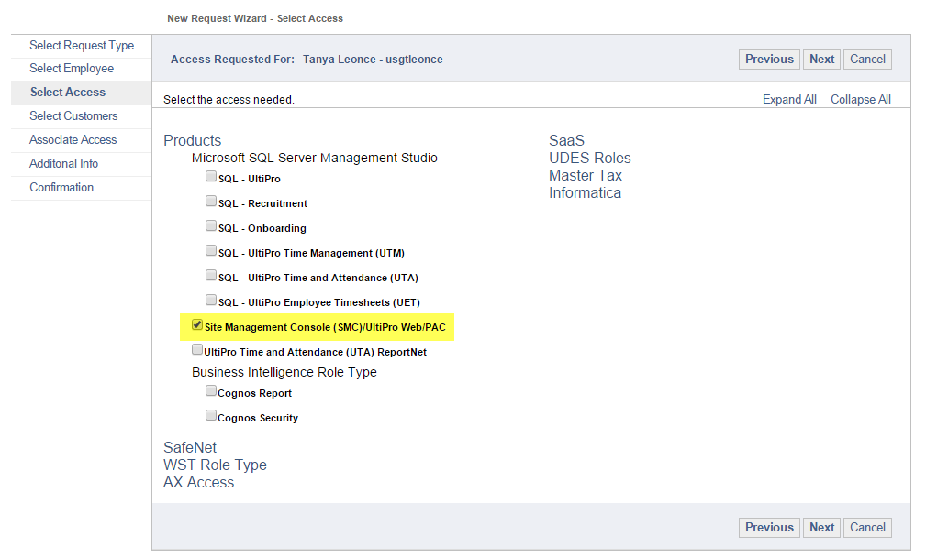

1. For Select Customers, search for customer by AR Number and then check boxes for Environments. See Below:

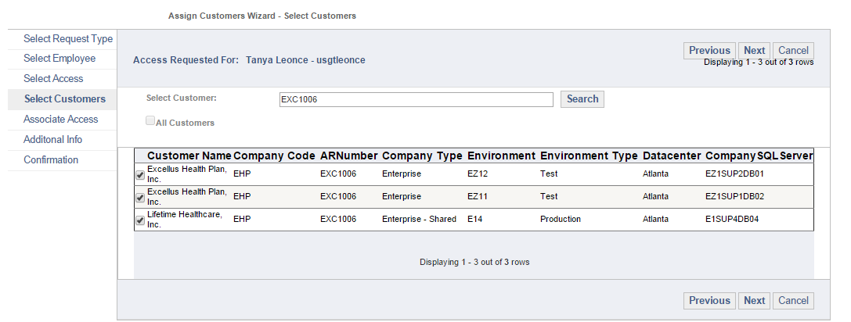

1. For Associate Access, then confirm all boxes are checked, then click Next.
2. For Additional Info, then add Comments (i.e., BulkAdmin for Custom SQL Import), then click Next.
3. For Confirmation, confirm everything looks correct, then click Save.
4. Once you get approval from WST, then you can log into Web Portal.